NH Orthopaedic Society
Annual Membership Dues

INVOICE

2026

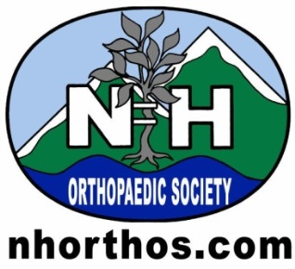

Advocating for high quality musculoskeletal care for the citizens of New Hampshire.
To promote harmonious moral and ethical standards together with fellowship and good will among its members.

Please make checks payable to NHOS

Two Capital Plaza, Ste. 401
Concord NH 03301
603-224-7083
Fax 603-226-2432

Catrina.watson@nhms.org

Date | Description | Balance | Amount Due
 | NH Orthopaedic Society Dues Emeritus | 100/ea

Your Leadership Team:

President – Frances Faro, MD Director – Neil Dion, MD
VP- Lance Warhold, MD Treasurer - Christopher Gentchos
Councilor – Robert Heaps Immediate Past President – Marc Michaud, MD

